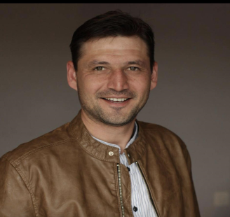 **SUMMARY**

|  |  |
| --- | --- |
| **Personal Details:** |  |
| Name | Ratmir |
| Last Name | Hudayberdyyev |
| Place of birth | Turkmenistan city of Turkmenabat |
| Family status | Married |
| Children | 3 |
| Health status | Excellent |
| Chronic diseases | Absent |
| Criminal record | Absent |
| Driver’s license | A B category |

|  |  |
| --- | --- |
| **Education:** | **Degree Name:** |
| **National Technical University of Ukraine**  Ukraine city of Kiev  2001-2007 | Bachelor of Mechanical engineer (Diploma) |
| **Huyndai Motors Technical Gollege**  South Korea City of Chonan  2010 | Mechanics courses:  Courses were completed on repair and operation of diesel engines (Certificate) |
| **Cukurova Makina Inşaat**  Turkey city of Adana  2010 | Mechanics courses:  Courses on repair and operation of diesel engines and hydraulic systems (Certificate) |
| **ASA College**  USA city of New York  2017-2020 | English language (Certificate) |

|  |  |
| --- | --- |
| **Work experience:** | **Job position:** |
| **Turkmenistan company “Ak Toprak”**  Construction machinery  Turkmenistan city of Ashgabat  2009-2011 | Mechanic:  (Control and repairing construction vehicles,  ordering spare parts for construction equipment Cukurova and Huyndai, acceptance of new equipment, sale of constructıon vehicles Cukurova and Huyndai). |
| **Turkmenistan company “Yol Inşaat”**  Road construction  Turkmenistan city of Turkmenabat  2011-2013 | Chief Mechanical Engineer**:**  (Control over the production of roads and construction equipment, preparation of  documents for road construction, control over mechanization workers, delivery of objects to the customer) |
| **Ukrainian company “Altkom”**  Road and Airport construction  2013-2017 | Mechanic:  (Control and repairing construction vehicles,  control over mechanization workers, ordering spare parts for construction equipment,  acceptance of new construction equipment) |
| **“Turkmen Star” Company**  Production of cable products  2021-2023 | Foreman:  (Control over the production of cable and control over cable production equipment) |

**Personal qualities:**

Purposefulness Sociability Aspiration Desire to learn

**Interests:**

Cars Construction vehicle Learn something new

**Languages:**

Russian(fluency) Turkmen(fluency) English(fluency) Ukrainian(fluency) Turkish (colloquial)

**Contact details:**

Email: [ratmir.khudayberdiev@gmail.com](mailto:ratmir.khudayberdiev@gmail.com)

Phone: +993 62768356