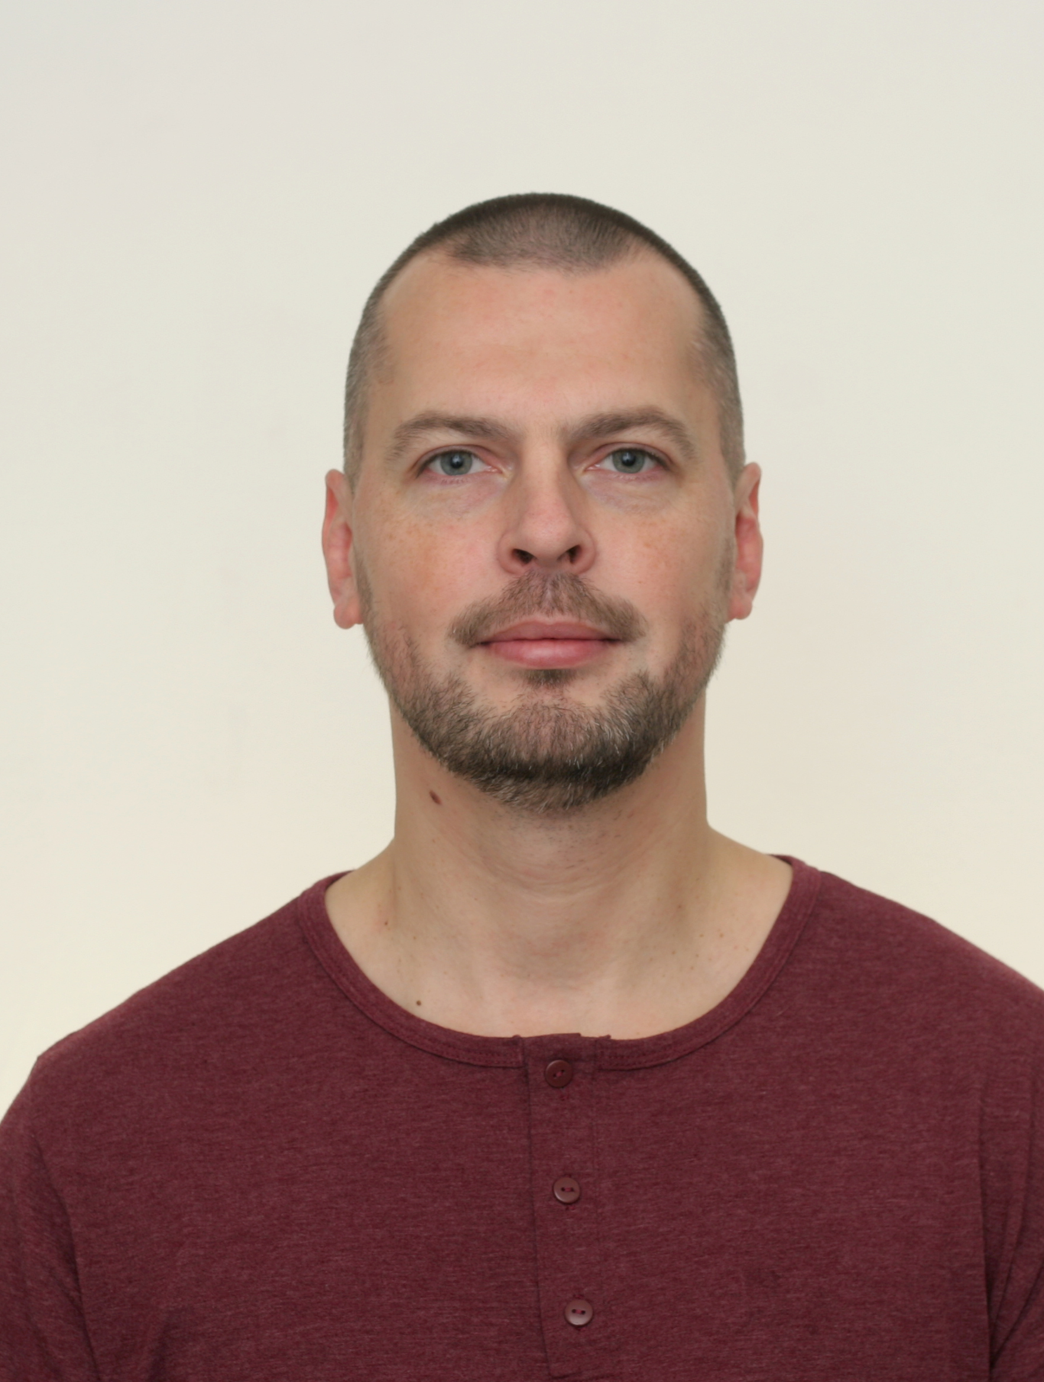 |  | KOROLEV YURY  Male, 42 years old  Date of birth: 11.03.1977  Marital status: married  +7 (985) 138-31-42  Moscow, Russia  w9851383142@yandex.ru
Target: Position as a carpenter, master of construction works
Previous Experience
2014 — till present  5 years |  | Architect  Moscow  Joiner-installer  Duties:  - Wood furniture production from valuable materials.  - Restoration.  - Assembly of furniture with using household appliances.  - Plumbing and electrical work.
2007 — 2014  7 years |  | Sole proprietor  Manager  Duties:  - Wizard for installation of translucent structures.  - Interior decoration.  - Negotiation with customers, signing of contracts.  - Joinery, installation of doors.
2003 — 2007  5 years |  | Company «Eurodom»  Construction engineer  Building houses of using cylindered timber and profiled beam according to Canadian technology.  Design and installation of foundation.  Design of the central and major distribution systems.  Interior fit-out.  Duties:  - Work at several construction sites.  - Obtaining approvals, negotiation with customers.  - Development of a strategic approach to customer needs.
Education
2017-2018  1995-2003 |  | Peoples' Friendship University of Russia  MBA course.  Moscow State University of Civil Engineering  Civil engineer.
1992-1995 |  | College №49 Carpenter, cabinetmaker.
Key skills
Language Abilities |  | Russian — Native  English — B1 — Intermediate
Skills |  | MS Word  MS PowerPoint  MS Excel  Driving License (Category A, B, C)  АvtoCad
Personality
Achievements  About me  Professional qualities  Professional skills |  | - Under my leadership, more than 58 houses were built.  - In 2009, a tender for the construction of children's playgrounds was won.  - More than 200 residential and office rooms have been renovated.  - More than 3000 square meters of installed translucent structures (windows, doors, winter gardens).  Hobbies: chess, manufacturing of interior items, fitness, tourism. Analytical mind, responsible, sociable, friendly, a team player, punctual, independent.  - Working capacity.  - Ability to take responsibility.  - Meeting deadlines.  - Organizational skills.  - Multitasking.  - Installation of drywall, laminate;  - Electrical work;  - Manufacture and installation of joiner and plastic products;  - Roof covering installation (soft roof, metal tiles, flooring, natural tiles)

